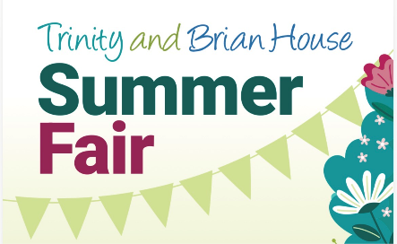
Assessment Title: | Trinity Hospice Summer Fair – Event Volunteer
Name of Assessor(s): | Jo Fowler | Issue Date: | June 2026

Hazard | Controls in Place
Communication | Your pre-event point of contact at Trinity Hospice is Jessica Blake-Uttley - Volunteering Manager: 01253 952576 jessica.blake-uttley@nhs.net  Your event day point of contacts are: Katy Nelson  07827 857987 & Gemma Webster 07784 231823
First Aid: Minor medical issue | First Aid will be available on site. Should you or any members of the public require any minor medical support (e.g. fatigue, falls, small injuries who is breathing and conscious) please contact your Trinity representative who will contact the nearest First Aider.
First Aid: Medical emergency requiring an ambulance | In any life-threatening medical emergency situation (e.g. unconscious member of the public not breathing) that requires an ambulance please dial 999. Please then report the incident your Trinity representative.
Emergency situations – Fire/ bomb/ security threats | Area to be checked for suspicious packages.  In the event of an emergency:  In-patient unit – Sister on duty will be in charge and advise patients and/or their visitors.  Outside/hospice gardens –Head of Fundraising will assess the situation and make announcements over microphone – staff/volunteers on duty will assist public to appropriate place of safety.  Volunteers briefed to assemble in garden & await further instructions.  Fundraising & Housekeeping communicate throughout event.
Tiredness or dehydration | You will have access to water and a food/drink voucher will be provided to you.  If you or anyone else becomes tired, ill etc. contact the Trinity representative immediately
Assault/verbal abuse from members of the public | Adequate number of volunteers working together.  Volunteers instructed not to take risks and to contact reception if incident occurs.
Adverse Weather | As the weather can be changeable you are advised to dress appropriately for the day including waterproofs if needed or sunscreen/hats
Ground Surfaces  (un-even surfaces/manholes)/ Slips & trips/walkways | The ground in areas around the garden can be uneven and on different levels. Please take care around the grounds. Signage where appropriate will be used. Cones and tape to be used where necessary.
Lost and found property | If any lost property is found, please hand to the Trinity Main Reception

The above risk assessment summary outlines the potential hazards, risks and control measures in place at the event.
Volunteers must review the above risk assessment and confirm acceptance by completing the acceptance form online at:
https://www.trinityhospice.co.uk/our-events/summer-fair-risk-assessment/

Any questions or queries please email trinity.fundraising@nhs.net or call 01253 952558

